Student worksheet
Frogs for the future? – learning activities

These learning activities use the article ‘Kimihia Kermit’ by Philippa Werry. You can read the article using Google slides or this PDF. You can also listen to an audio recording of the article.

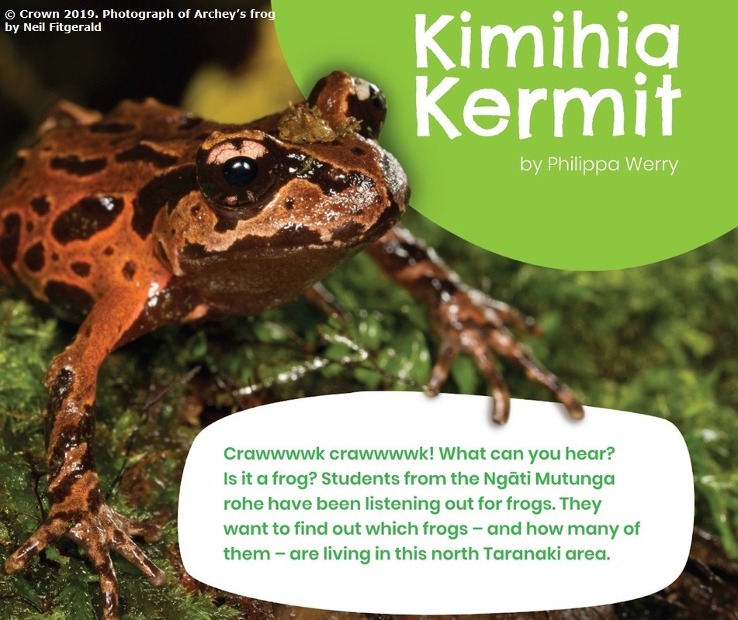

Before you read

Look at the images in the story. Use them to help you answer these questions:

- Look at the title and the image on the front page. Kermit is a famous character. Why do you think his name has been used?

- Now look at all the images in this article. What do you think this article is about?

- What message do you think the author might want the reader to get?

- What are you curious to find out more about?

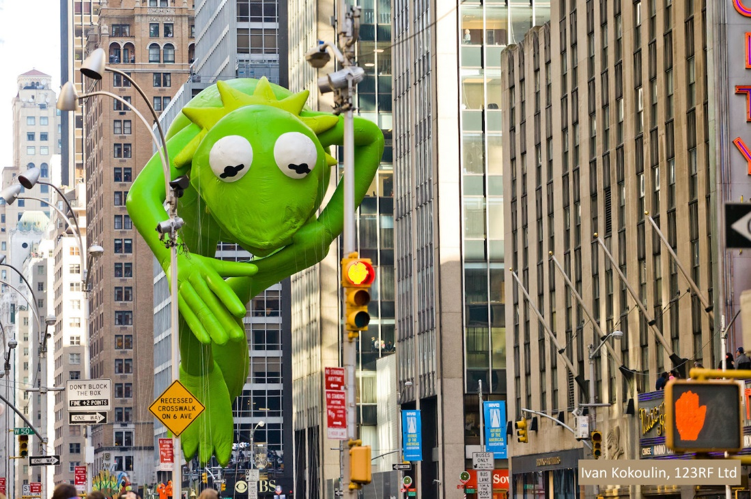

While you read

Think about these questions

      - What does this team of people want to find out and why?

      - Why do you think the team included three schools?

      - How will this work help the frogs and the people involved?

After you read

Answer these questions:

- What were the two research questions?

- Why do you think there was concern for the frogs?

- What sort of information or data was collected?

- How was the data collected?

- What did the data tell the scientists?

- What questions do you have about what was found out?

- How could you find out some answers to your questions?
Frog facts – slide 3

Use the information on slide 3 to match the words below to the pictures you see. Draw a line between the word and the picture.

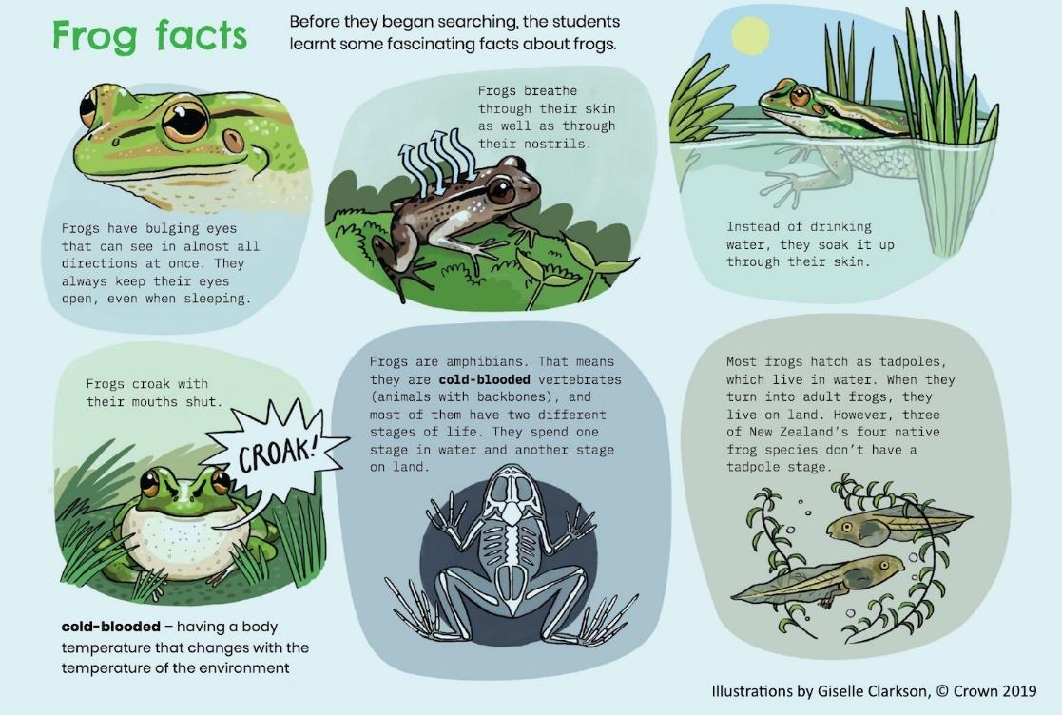
life cycle

respiration

communication

classification

hydration

protection

Frogs in New Zealand – slide 4

This is a scavenger hunt using information on slide 4. Write down the name of the frog that matches each description.

This frog lands on its face when it jumps
This frog is the largest in Aotearoa
How many species of native frogs do we have?
Pepeketua is the Māori word for what?
Which frog is endangered worldwide?

Similarities and differences

Look at the image of the introduced southern bell frog on the left and the native Maud Island frog on the right.
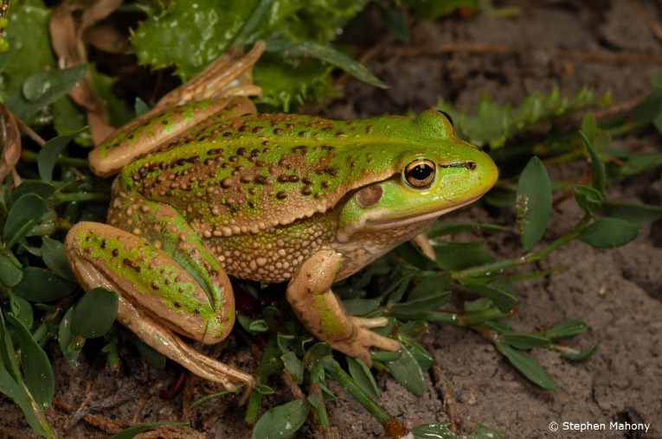
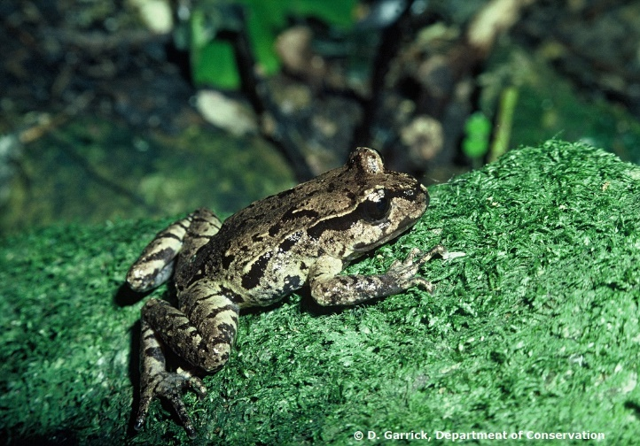
Use the table to record three similarities and three differences between the frogs.

Similarities | Differences

Acoustic survey – slide 6

Scientists often use technology to help them collect data. Patrick, the ecologist, made observations by listening. He also used an acoustic recorder to collect recordings of animal sounds to identify the locations where frogs were living.

Let’s look at the acoustic recorder. This table lists the features of the recorder. Fill in the table with your ideas about why the features are useful.

Acoustic recorder features
Feature | Useful for
Waterproof
Long battery life
Display that shows date and time
Metal cage around microphone
Memory card
Strong plastic case
Frog distribution map – slide 7
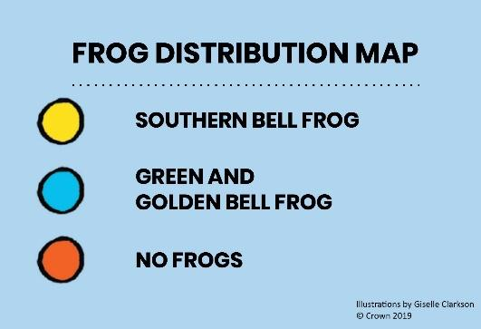
Look at the map on slide 7. Scientists often use diagrams to help them share information. Diagrams often use a key to explain what the symbols mean.

This map also has orange and blue lines and some light and dark green areas, but this information is not given in the key.

What do you think each of these colours might mean? Put your ideas in the table below.

Map marking | What I think the map marking means

Who’s calling? – slide 7

The call of the green and golden bell frog and the southern bell frog are different.

      - Why do you think the two frogs might have different calls?

      - The text describes how to make the two frog calls. Have a go at sounding like each of these frogs. Make a video or sound recording of your calls.

Why are frogs in danger? – slide 8

The pepeketua and poraka in North Taranaki have gone quiet, perhaps due to threats.

- Which of the threats to the frogs are caused by people?

- Which of the threats are from other native animals?

Working together to help the frogs

This article is also about people who are participating and contributing, working together and helping. Who took part in this investigation, and how did each group show kaitiakitanga?

Additional activities

Do you hear frogs near your place? Perhaps you could go outside at the right time of day and listen? You might want to take someone with you.

How could you find out more about frogs around your area? Who would be good to talk to?

- Three of the students made suggestions about things that could help frogs in their area. Which one would be most useful for you in your area?

- How could you show kaitiakitanga in your area? What part of your natural environment might need some care to be a better place for our native plants and creatures?

- You could have a go at making an origami frog that actually jumps – see the activity here.

Useful links for students

Use these resources to learn more about Aotearoa’s native frogs:
- https://teara.govt.nz/en/video/10003/archeys-frog-with-froglets (Te Ara)
- https://www.youtube.com/watch?v=gRasIH6muiU (Zoo Tales)
- https://www.youtube.com/watch?v=hOlO2FoRqXQ (Archey and Friends – a helping hand for the future).
- https://www.youtube.com/watch?v=77qaf4X4sek (a video produced by two young girls, Brylie and Nikita, from Ngātea Primary School)

