Student worksheet:
Science and partnership
with a Sāmoan village – learning activities

These learning activities use the article ‘Building for the future’ by Adrienne Jansen. Read it using Google slides or this PDF. You can also listen to the article.

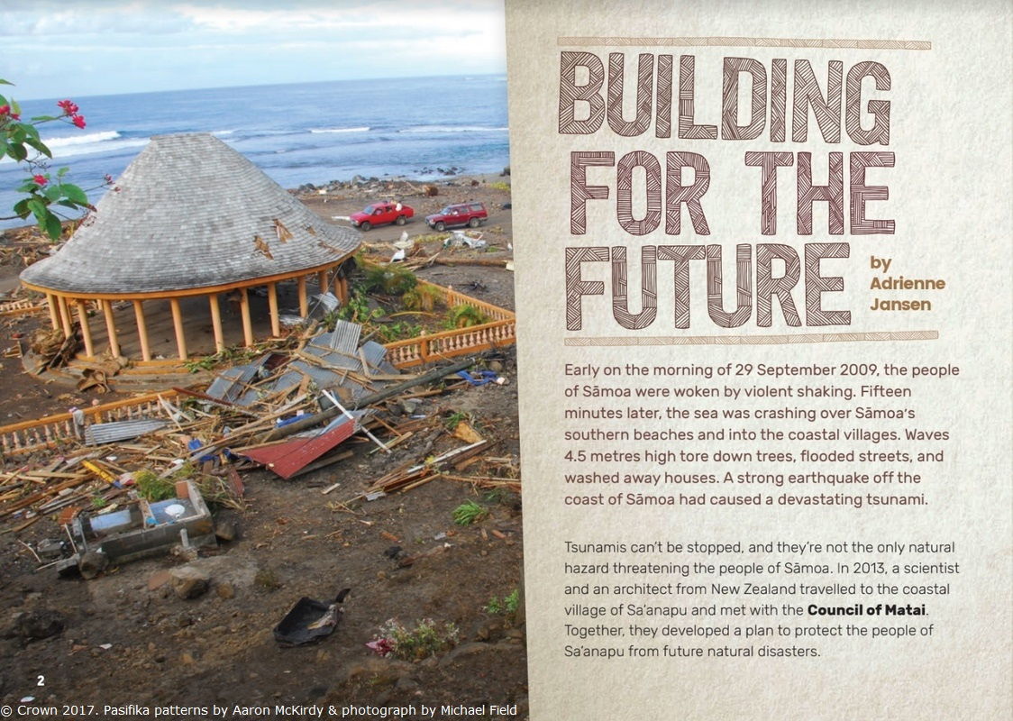

Before you read

- Look at the title and the image on the front page.
- What do you think you are going to be reading about?
- Did you notice the font of the title?
- How might that be an important choice?

- What do you know about Sāmoa? Write down five words that say something about Sāmoa.

- Tsunamis cause problems. Write five words that suggest some of the problems of tsunamis.

While you read

Think about these questions:

- Think about the different people in this article. How are their points of view different?

- This article talks about people from Sāmoa and people from New Zealand. These two groups have different responses to the flooding problem. How are the responses the same and how are they different?

- How do the diagrams help you understand what is going on?

After you read

Challenges facing Sāmoa

- Thinking about what you have read, what are the reasons for the village to stay where it is, and what are the reasons for it to shift? Record your ideas in the table.

- If you can think of extra ideas that the article hasn’t mentioned, add these in the bottom of the table.

Keep Sa’anapu village where it is  – what the text says | Shift Sa’anapu inland  – what the text says
My ideas why they might want to keep Sa’anapu village where it is | My ideas why it could be good to shift Sa’anapu inland

Using models, diagrams and maps

Scientists often use diagrams and models to clearly share their thinking with others.

      - Look at slide 2 (A village under threat) and write 3 sentences to tell the information from the map. Remember when looking at maps, be sure to read the key. You will need to talk about this information in your sentences.

- What problems does the map of Sa’anapu show?

- Looking closely at the map, the dotted lines that show how the coastline is moving look to be about the same distance apart, but is the difference between the dates the same? Look at the dates for each of the coastlines. Position those dates on the timeline below:

1912 2014

- When did the coastline have the fastest change?

- Slide 5 (Tsunamis: The biggest threat) shows a model of how a tsunami wave might hit the coastline.
- Why do you think Geoffroy created a computer model?
- What different sorts of information would the village people have about tsunamis?

- These scientists used a different type of model – cakes! Write one comment about the usefulness of cake as a way of sharing your thinking.

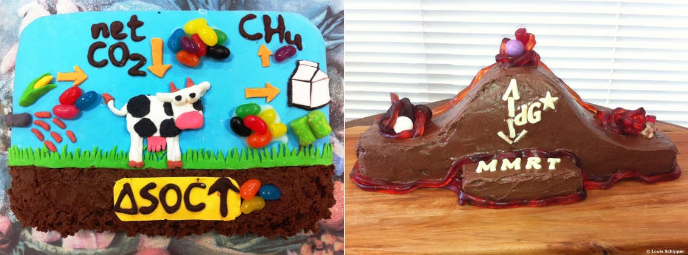

Fale technology and design
A Sāmoan fale has a lot of excellent features that makes it safer in a storm than a traditional New Zealand house with its corrugated iron roof, windows and nailed structure.
In the table below, show why or how these features are useful for houses that may be subject to tsunamis in a tropical area.
Fale feature | Benefits to daily Sāmoan life and in tsunamis
Timber structure not nailed together
No solid walls
Roof made of palm fronds
Panels that roll down made of palm fronds woven together

Wicked problem – should they stay or should they move?

Slide 8 tells us that most of Sāmoa’s people live on the coast.

      - Why do you think many villages are on the coast?

      - What needs are met by living on the coast?

      - What advantages would an inland move offer the people?

      - What would they miss out on?

      - Write a letter to the people of Sa’anapu advising them what you think they should do and why. You need to use scientific information but also address their concerns about leaving their traditional land.

      - In te reo Māori, there is a concept called ako, which is to teach and to learn. How did Geoffroy the scientist, Cecile the architect and Tupu the Talking Chief teach and learn/ako from each other?

Additional activities

Model making

Model making is an important part of science to check understanding and to share findings with others.

- Can you make a model like the one on slide 6? You might have a big tray at home that you could use and put some soil in it and press it down. Then put in water and move it to make waves like in the diagram. If you change the soil for sand, what changes?

- Can you build a model house using just sticks and string? Scientists often learn more about the investigation when they make a physical model. After you’ve made a model:
- Draw a diagram of the structure you made.
- Which parts worked well?
- Which parts were challenging?
- Compare challenges of building with sticks and string with challenges of building with LEGO.
- Compare your model to the fale design.

Here’s an example:

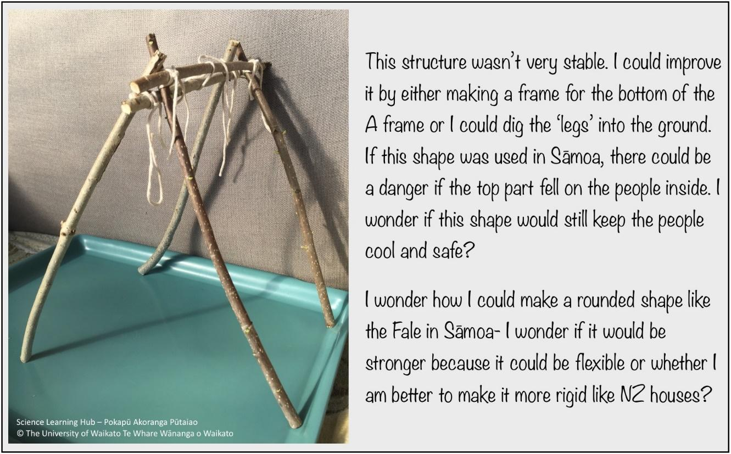

Te reo Māori and Gagana Sāmoa
Did you know that in te reo Māori, tai means seaward and uta means towards the shore? Given that Sa’anapu-tai is the one nearest the sea and Sa’anapu-uta is on the landward side, it looks like it has a similar meaning in Gagana Sāmoa (the Sāmoan language). If you see or hear Gagana Sāmoa in your daily life, can you find any other similarities between Gagana Sāmoa and te reo Māori?
Tsunamis
GNS Science works to understand Earth systems such as tsunamis. There is information on their website of what to do in the event of a tsunami. Use this information to design two posters – one for locally generated tsunamis (these are tsunamis that have arisen because of a nearby earthquake) and one for long-distance tsunamis (these are ones that the scientists’ equipment have picked up out in the ocean). Remember to include the symbol for the tsunami hazard zone.

